|  |  |
| --- | --- |
| **Name** | **Enayathulla A** |
| **Date** | **10/01/2024** |
| **Type** | **Daily Assignment** |
| **Topic** | **Create a sample YAML pipeline** |

**YAML pipelines:**

YAML is a data serialization language often used for writing configuration files. Its name stands for “Yet Another Markup Language.”

One of the main advantages of YAML pipelines is the ability to review every change made to the pipeline since its creation.

It’s also possible to compare a malfunctioning definition with the last known working definition. This helps resolve issues in the build more efficiently and reduces recovery time.

**Creating a sample YAML pipeline:**

Step1🡺Go to Azure DevOps page.



Step2🡺Create One sample organization. (Enayathulla-BIBA)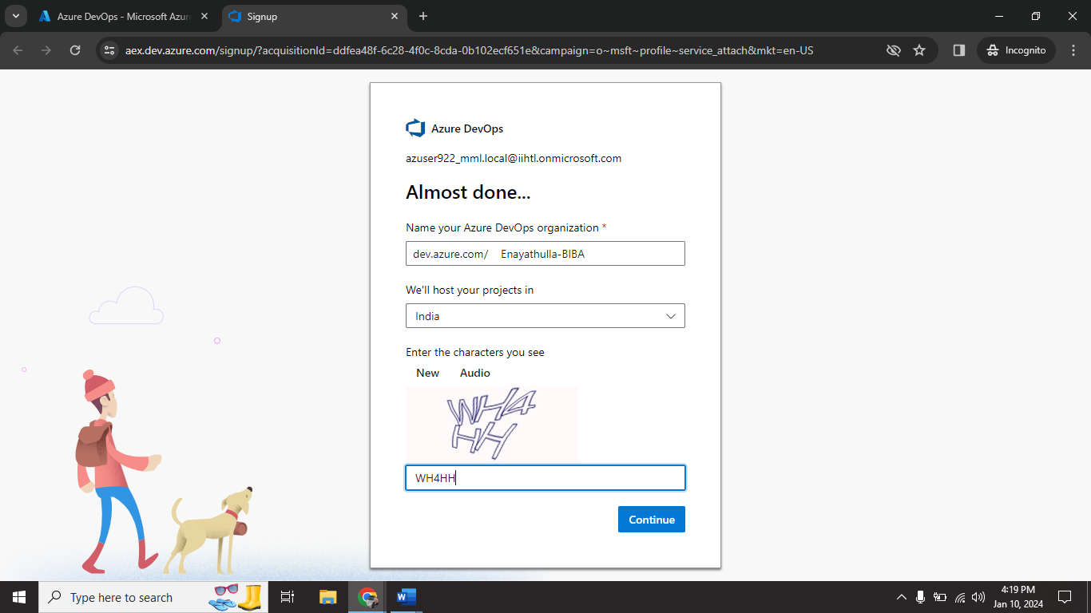

Step3🡺 create one sample project. (Enayathulla-Project)

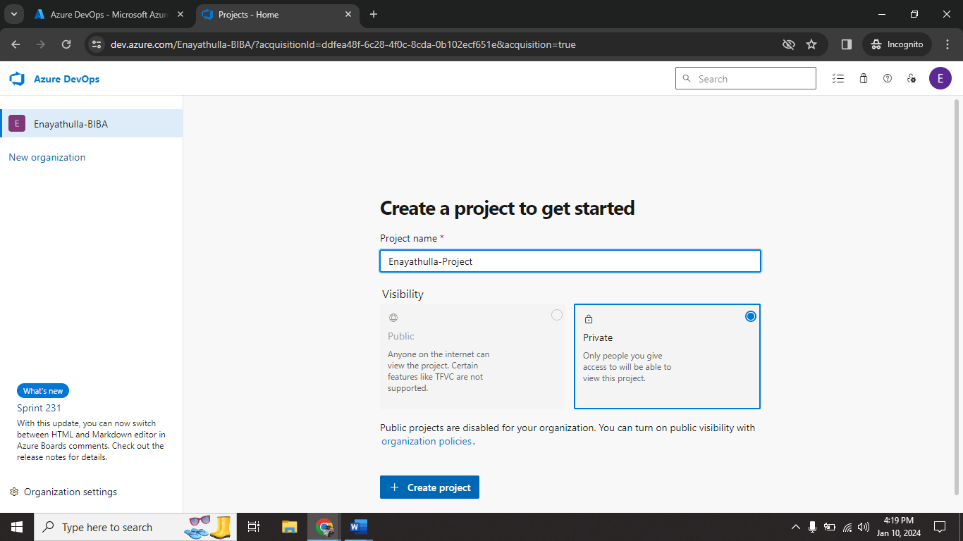

Step4🡺go to pipelines click on create pipeline.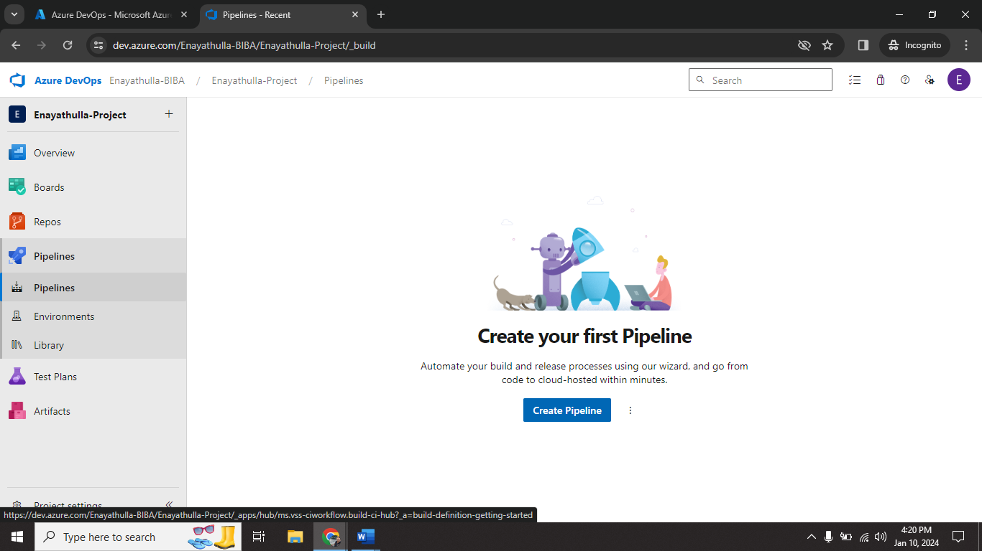

Step5🡺 Click on Azure Repos Git.

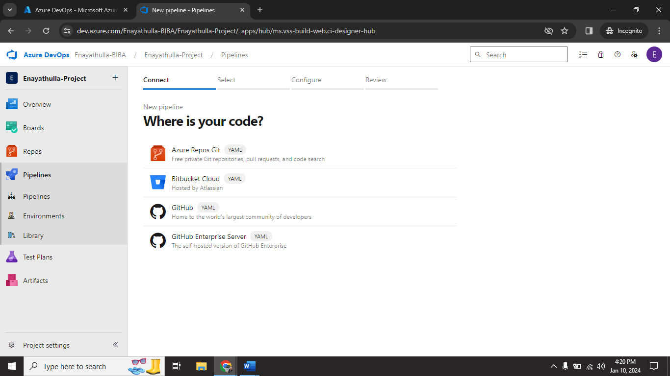

Step6🡺select a repository. (sample1)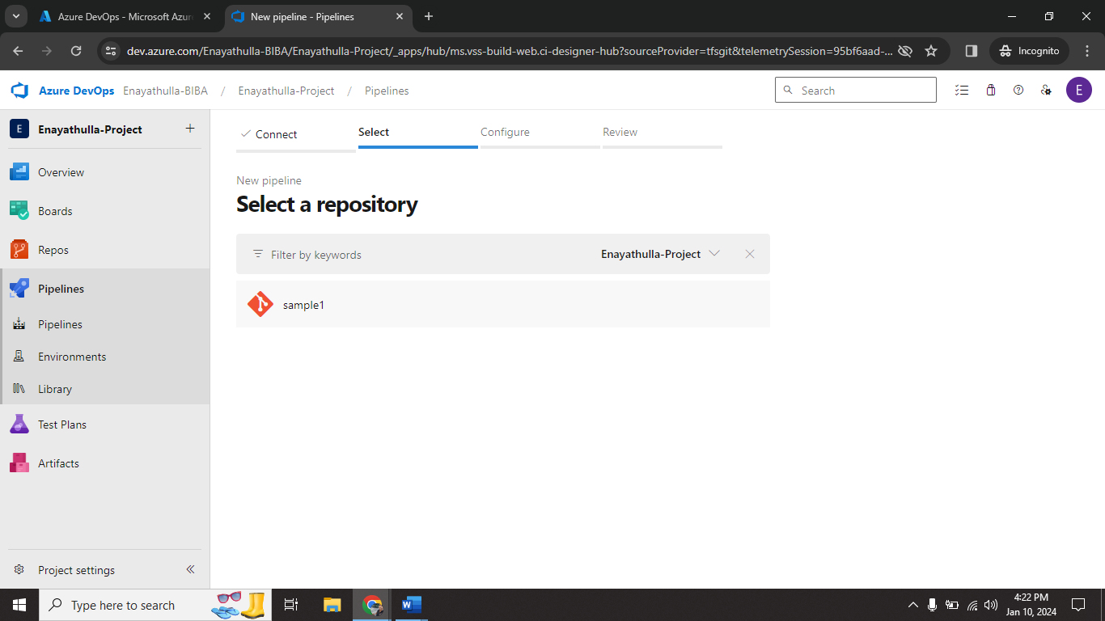

Step7🡺 select Starter pipeline.

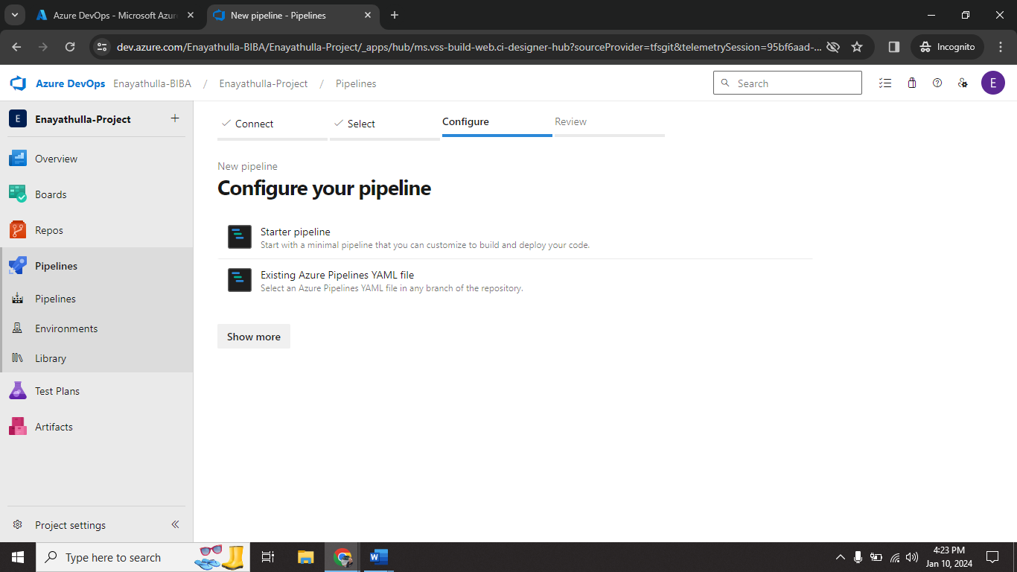

Step8🡺click on Save and run.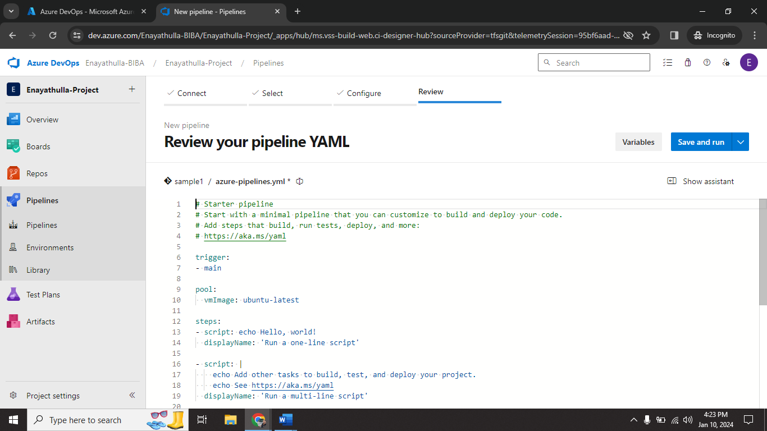

Step9🡺 give commit message and click save and run.

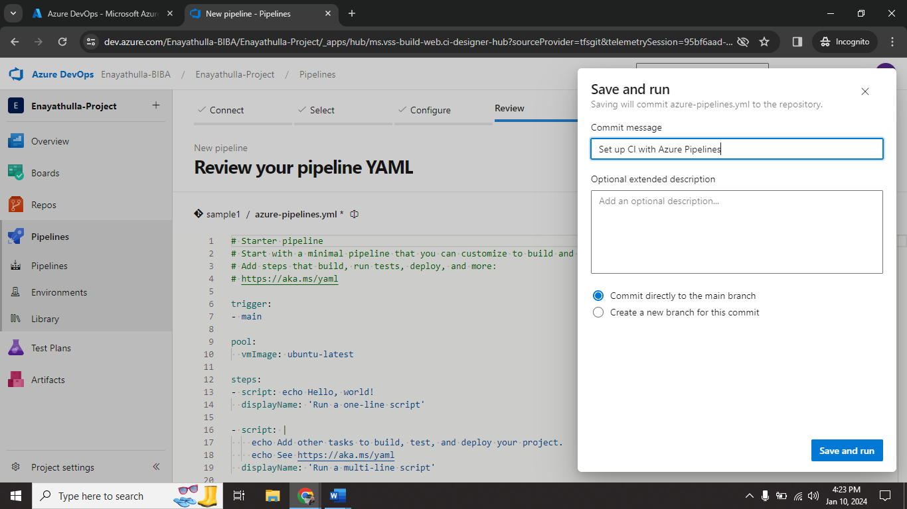

Step10🡺YAML pipeline successfully created.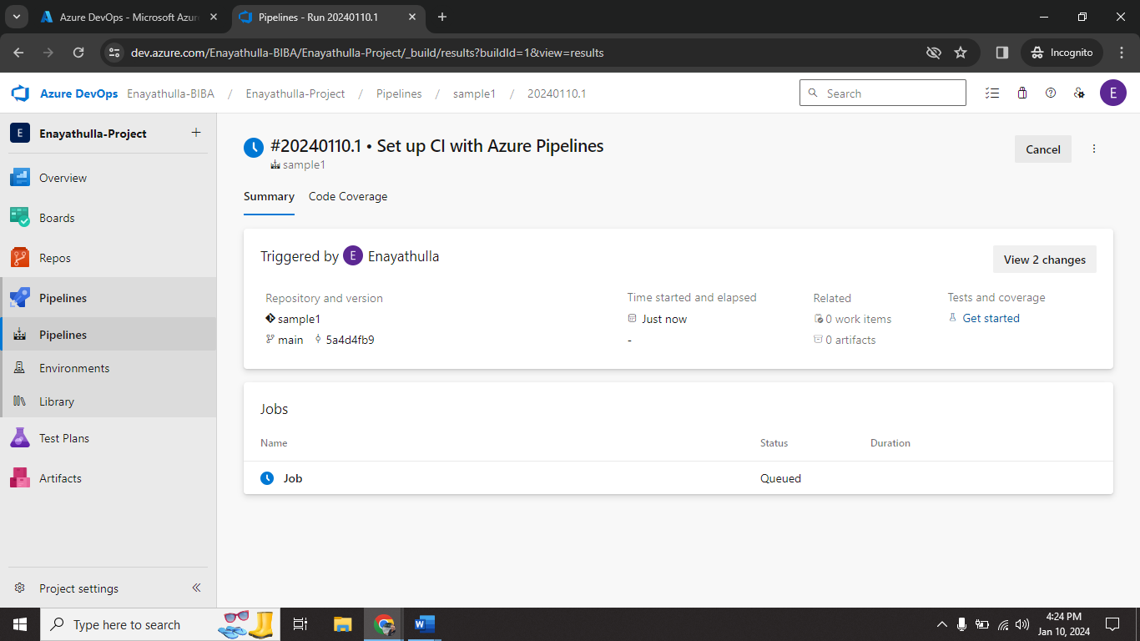

Step11🡺 After completing all task delete the Organization.

